Department of Nuclear Engineering
Chittagong University of Engineering and Technology

- Nuclear Simulation Lab
- Environmental and Radiation Safety Lab
- Nuclear Materials Science Lab
Proposed Three Fundamental Lab

Lab Equipment

Department of Nuclear Engineering
Chittagong University of Engineering and Technology

NUCLEAR MATERIALS SCIENCE LAB
Equipment 1: Digital Weight Machine: Analytical Balance Model: LSD-320A

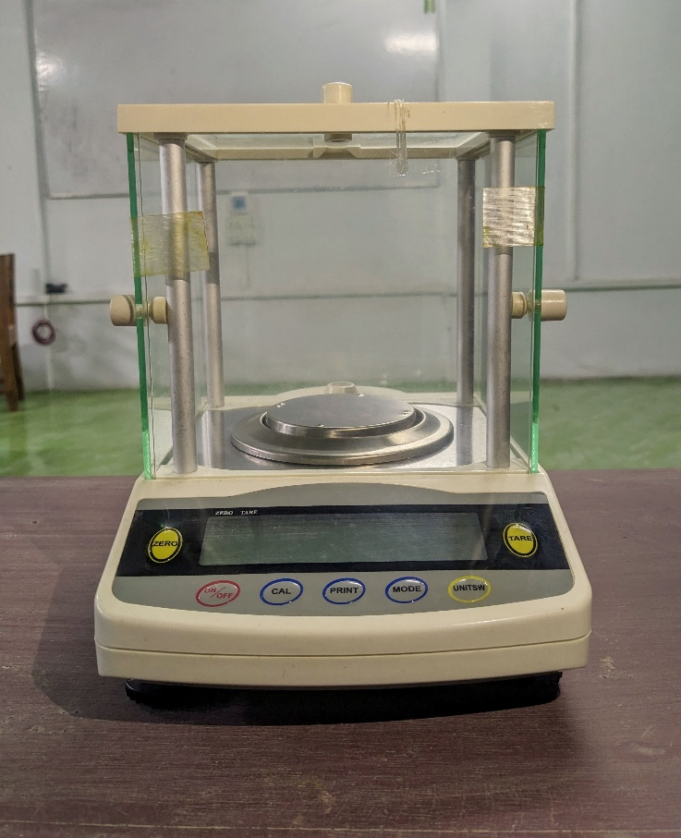

Analytical Balance Model: LSD-320A
Readability: 0.001g
Capacity: 320gm
Power DC: 9V
The Digital Analytical Balance model LSD-320 likely possesses several features that make it a valuable tool in analytical laboratories.

Equipment 2: Forced Air Drying Oven (BIOBASE )
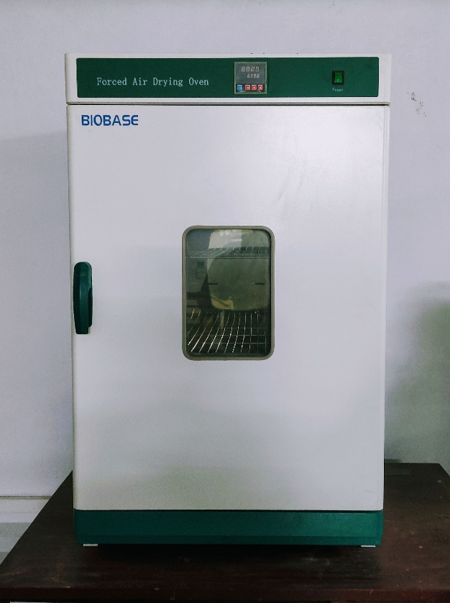
Forced Air Drying Oven
Features :
- External material: cold-rolled steel with anti-bacteria powder coating.
- Stainless steel inner chamber, round angle structure, adjustable shelves.
- PID microprocessor intelligent temperature controller.
- Over-temperature protection.
- Optional independent temperature protector and RS485 for FI series.

Model : BOV-V230F
- Capacity : 230L
- Temperature Range : RT+10~300℃
- Temperature Precision : 0.1℃
- Temperature Fluctuation : ± 1℃
- Ambient Temperature : 5~40℃
- Timing Range : 1~9999min
- Shelves No. 2 pcs
- Display : LED
- Consumption : 3000W
- Power Supply : Standard : AC220V ± 10%, 50/60Hz; Optional : AC110V±10%, 60Hz

Equipment Size :
- Internal Size : 600*500*750 (W*D*H)mm
- External Size : 730*670*1220 (W*D*H)mm
- Package Size : 770*840*1420 (W*D*H)mm
- Gross Weight(kg) : 103.5

N.B: For more details. Please visit website BIOBASE forced Air Drying Oven

Equipment 3: HYSC (MUFFLE FURNACE Model: MF-05 )
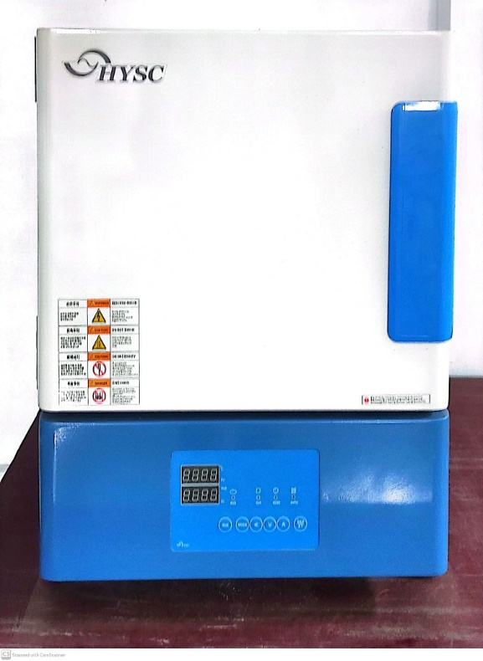

Use
This product is used for various purposes such as the development of new materials, superconducting materials experiment, ceramic sintering, heat treatment, melting of the glass, melting the metal and casting molding.

Features
– Fuzzy function to prevent overheat.
– Accurate temperature controls by Digital PID controller.
– Controller select time scale (99 mininute 59 second, 99 hour 59 minute, 99 day 23 hour)
– In case of temperature sensor disconnection, error message appear.
– Alarm rings when timer end.
– In case of difference between real temperature and appeared temperature, user can adjust correctly. When controller setting value is changed by the mistake of operation, save and recall function can restore it early.
– High temperature test up to 1000C ( Max. Temp:1200C)
– High performance heat insulation by the molded ceramic block and quick reach to high temp.
– Air vent port is installed between the ceramic fiber heat shield and furnace exterior case and it prevents exterior heating.
– Insulation support to prevent internal pollution and damage.
N.B: For more details. Please visit website Furnace hysc

Equipment 4: Digital Hotplate Stirrer: SCILOGEX SCI550-Pro

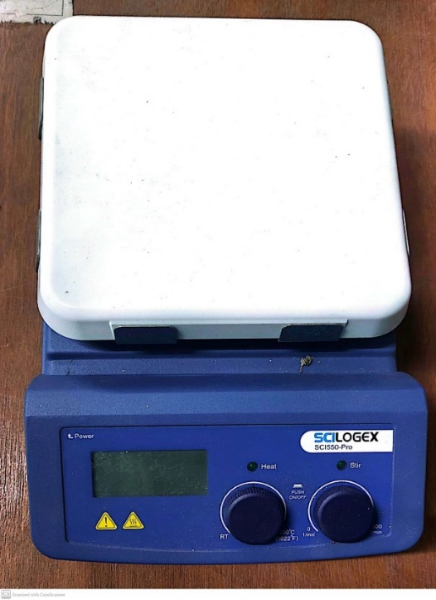

Product Description: the SCI550-Pro is one of the most technically advanced hotplate-stirrers in the marketplace. With independent back-lit LCD displays for both heat and stirring functions and PID technology. The SCI550-Pro controls temperature at +/- 1ºC. It also incorporates a DC brushless (spark free) motor for extremely long life and excellent performance. It is widely used in chemical synthesis, physical and chemical analysis, biopharmaceuticals etc. Combining with glass ceramic work plate, brushless DC motor and external temperature sensor, the work plate temperature is optimized up to 550°C.

Product Features
Easy-to-read independent back-lit LCD displays for heat and stirring.
- Digital speed controlling, max. speed at 1500rpm
- Built-in PID controller ensures safe heating of the medium with overheating protection.
- Heat only, stir only or heat and stir together functions.
- Max. heating plate temperature 550°C
- Glass ceramic work plate provides excellent chemical resistant performance and most efficient heat transfer.
- RS232 for remote control, providing PC control and data transmission.
- Low temperature stability
- External temperature control is possible by connecting the temperature sensor (PT1000) with an accuracy at ±0.2°C.
- Accessory PT-1000 stand available (built in stand mount)
- Electronic speed control for constant speed even during changes in load
- Maintenance free DC brushless motor for long life and more stirring power
- Two rotating knobs enable easy adjustment of speed and temperature.
- High magnetic adhesion
- “HOT” warning will flash when the work plate temperature is above 50°C even when the hotplate is turned off.
- cTUVus approved for UL and CSA
- 2 YEAR WARRANTY
N.B: For more details. Please visit website Hotplate stirrer

Equipment 5: Hydrothermal Synthesis Reactor

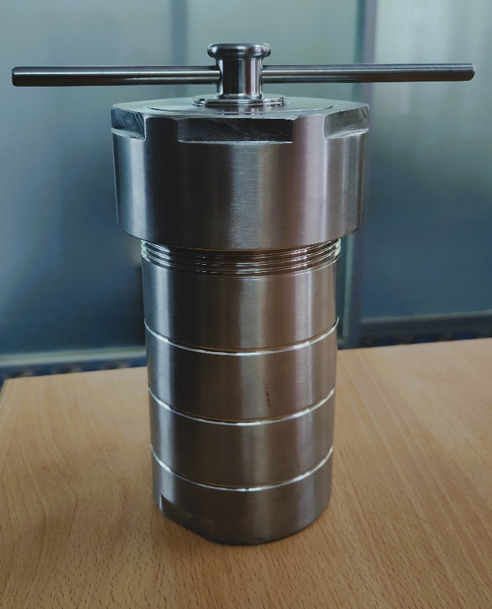

1. Introduction
Hydrothermal synthesis reactor is a kind of closed vessel which can decompose insoluble substances. It can be used for sample pretreatment in atomic absorption spectrometry and plasma emission analysis, small dose synthesis reaction, and fast digestion of insoluble substances in the closed environment of high temperature and high pressure with strong acid or alkali in the tank.
The samples were pretreated in the chemical analysis methods of gas phase, liquid phase, plasma mass spectrometry, atomic absorption and atomic fluorescence.
It can be used in the determination of heavy metals such as lead, copper, cadmium, zinc, calcium, manganese, iron, mercury, etc. it can also be used as a high-temperature, high-pressure, corrosion-resistant and high-purity reaction vessel, as well as organic synthesis, hydrothermal synthesis, crystal growth or sample digestion and extraction.
In the sample pretreatment, heavy metals, agricultural residues, food, sludge, rare earth, aquatic products, organic matters, etc. are digested. It is widely used in the research and production of petrochemical, biomedical, material science, geological chemistry, environmental science, food science, commodity inspection and other departments.

2. Composition
The hydrothermal synthesis reactor is composed of lower gasket, stainless steel outer jacket, inner lining (polytetrafluoroethylene or PPL), inner lining cover, upper gasket, stainless steel reactor cover, secondary fastening bolt and fastening force bar.

3. Performance
The body is made of 304 high quality stainless steel, sealed by round tenon and groove, and fastened by manual screw. It has the characteristics of good sealing and high safety factor. The external surface is polished with stainless steel mirror, with high smoothness and beautiful appearance.

Specific material characteristics as below:
1. High temperature resistance: PTFE temperature: -200~+220℃; PPL temperature:-200~+250℃
2. Low temperature resistance: -196℃ can maintain 5%
3. Corrosion resistance:corrosion strong acid, alkali, aqua regia and various organic solvents.
4. Insulation resistance: dielectric properties are independent of temperature and frequency.
5. High lubrication: the lowest friction coefficient among solid materials
6. Non-adhesion: Does not adhere to any substance; strong self-wetness; friction coefficient in solid materials is 0.04
7. Non-toxic: It is physiologically inert and can be implanted in the human body; it can be used in the atmosphere for a long time.
8. Anti-pollution: The blank value of metal elements is low, the lead content is less than 10-11g / ml, and the uranium content is less than 10-12g / ml
9. Anti-leakage: falling from a height of 1.2 meters above the ground, the bottle body does not break, the bottle cap does not fall off, and there is no damage and leakage

N.B: For more details. Please visit to website hydrothermal-synthesis-reactor

Equipment 8: Agate Mortar pestle

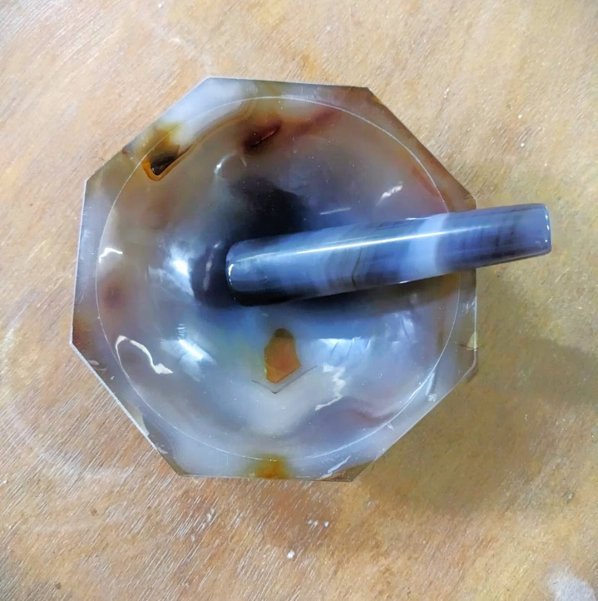
Product Application:
Agate mortar and pestle are commonly used in various scientific and industrial applications due to their unique properties. Here are some typical applications:

- Chemical Analysis: Agate mortar and pestle are commonly used in laboratories for grinding and mixing small quantities of chemicals, powders, and solid samples. They are especially useful when working with delicate or reactive substances that could be contaminated by metal particles from traditional metal mortars and pestles.
- Pharmaceuticals: In pharmaceutical laboratories, agate mortar and pestle are used for grinding and preparing small quantities of pharmaceutical compounds, including herbs, pills, and powders. They provide a contamination-free environment, ensuring the purity of the final product.
- Geological Sample Preparation: Geologists use agate mortar and pestle to grind rocks and minerals into fine powders for various analytical techniques such as X-ray diffraction (XRD), X-ray fluorescence (XRF), and chemical analysis. The use of agate prevents contamination of the samples with foreign materials.
- Material Science: Agate mortar and pestle are employed in material science research for grinding and mixing ceramic, glass, and other brittle materials. They are particularly useful when working with materials that require a contamination-free environment or when precise control over particle size is necessary.

Materials: some common reagents and solvents used in laboratory work:

ENVIRONMENTAL AND RADIATION SAFETY LAB

Equipment 1: Secondary Standard Dosimetry Laboratory
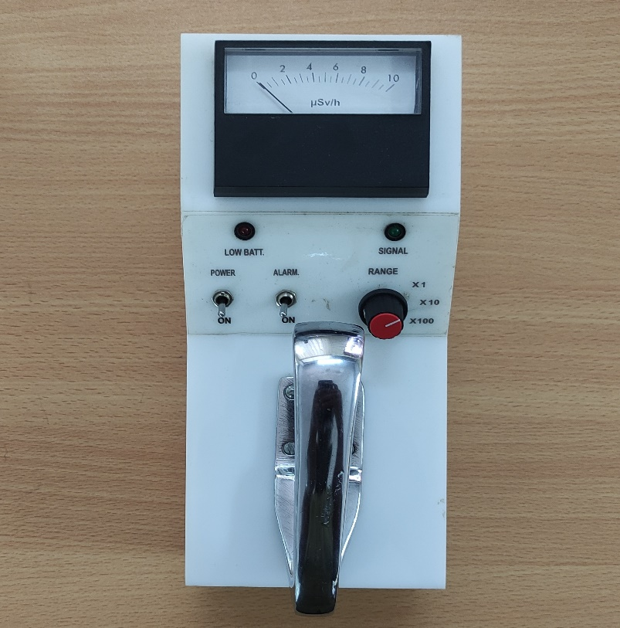

Secondary Standard Dosimetry Laboratory
Model: MDGE -11 S/N: 111901
User: Institute of Electronics (IE), AERE, Savar, Dhaka
Date of Calibration: 08 September 2021
Re-Calibration Due: 08 September 2022
Source Ranges CF (0-10)×1 μSv/h 0.999 137 Cs (0-10)× 10 μSv/h 0.974 (0-10)× 100 μSv/h 1.198
Secondary Standard Dosimetry Laboratories (SSDLs) play a crucial role in ensuring the accurate measurement of radiation doses, which is vital in various fields such as medical radiation therapy, industrial radiography, and radiation protection.
N.B: For more details. Please visit to Institute of Electronics, Atomic Energy Research Establishment, Savar, Dhaka.

Equipment 2: Gas Detector System

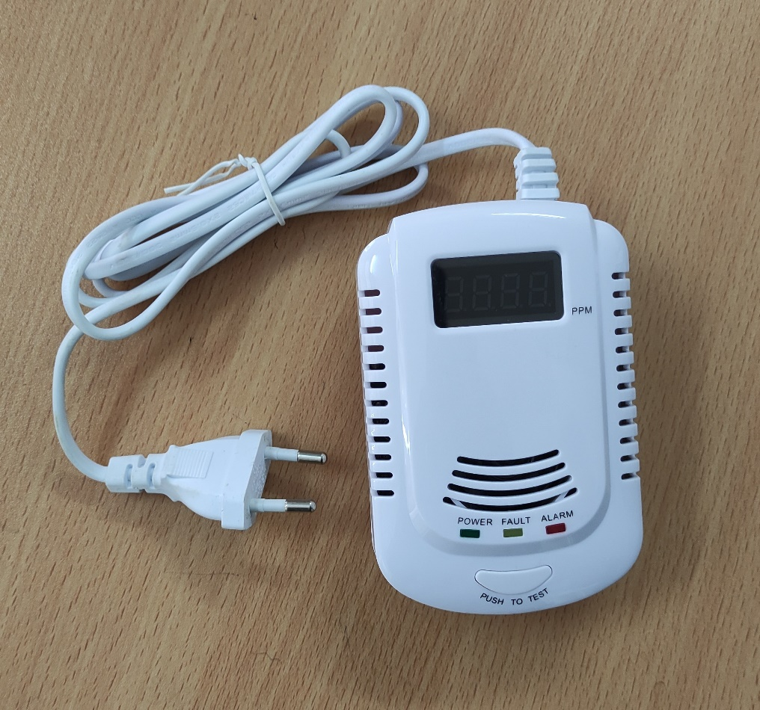

PRODUCT FEATURE
- Human voice prompt High reliable semiconductor sensor
- Gas concentration displaying (PPM)
- Power supply from AC 90V-240V or 9V rechargeable battery
- Intelligent microprocessor control
- Alarm memory function
- Auto detect sensor failure

Equipment 3: PRD/PRD-ER Personal Radiation Detector

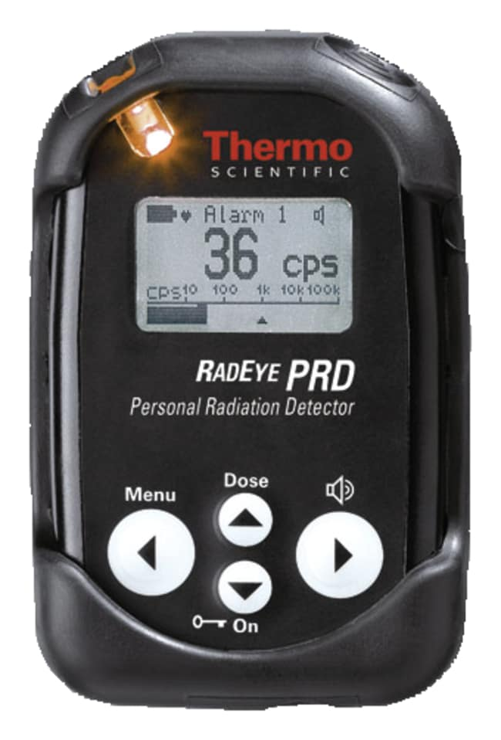

RadEye PRD Personal Radiation Detector
The RadEye PRD Detector is a high sensitivity gamma radiation detection and dose rate measurement tool for security forces, the steel and recycling industry, and first responders seeking to detect and locate orphaned sources or problematic NORM related sources in scrap yards, border crossings, and other public locations.
- 5000 to 10,000 times more sensitive than a typical electronic dosimeter; incorporates highly sensitive NaI(TI) scintillation detector with miniature photomultiplier for detection of very low radiation levels (emphasis on gamma emissions below 400KeV).
- Patented Natural Background Rejection (NBR) technology provides high sensitivity with high selectivity; eliminates nuisance alarming due to naturally recurring radiation sources (such as granite).
- Can be used as a search and survey tool.
- Can be used in a belt-loop holster for hands-free operation.
- Menu-driven with an intuitive, easy-to-use format.
- Low-power-technology components and fully automated self-checks result in minimum maintenance.
- Equipped with large, clear graphic display and audible/visible/vibrating alarms; earphone-output for silent alarming.
- Includes removable rubber sleeve for extra protection.
- Compliance: Designed to meet ANSI™ 42.33/1, 42.32 and IEC 62401.
RadEye PRD-ER Personal Radiation Detector
The RadEye PRD-ER Personal Radiation Detector is an advanced pocket-size instrument that detects and localizes radiation sources generated by man-made devices such as nuclear weapons, improvised nuclear devices (IND) or radiological dispersal devices (RDDs). Single detector arrangement offers the following unique advantages over the whole measuring range:
- Consistent angular dependence.
- No mutual shielding of neighbored detectors.
- Consistent energy response.
- No transition range with annyong hysteresis effects.
- No high-activity source for function test of high dose rate detector required.
- Menu-driven with an intuitive, easy-to-use format.
- Patented Natural Background Rejection (NBR) technology provides high sensitivity with high selectivity; eliminates nuisance alarming due to naturally recurring radiation sources (such as granite).
- Low-power-technology components and fully automated self-checks result in minimum maintenance.
- Equipped with large clear graphic display and audible/visible/vibrating alarms; earphone-output for silent alarming.
RadEye PRD/PRD-ER General Specifications
Detectors NaI(Tl)-detector with high-quality microphotomultiplier; software switch for R or Sv energy response and calibration.
Energy Range 60keV to 1.3 MeV, excellent detection from 30keV.
Count Rate For Cs-¹³⁷ (662 kev): 1.5 cps/μR/h (150 cps/μSv/h); For Am-241 (60 kev): 30 cps/μR/h (3000 cps/nSv/h).
Units cps, Sv/h, rem/h, R/h.
Dimensions L x W x H: 1.25 x 2.4 x 3.78 in. (3.1 x 6.1 x 9.6cm).
Weight 5.6 oz. (160g).

NUCLEAR SIMULATION LAB

Coming Soon

